What Is SAGA Pattern?
Microservices are very popular and vastly used in today's technology world. Implementing microservices is easy but complications start when the distributed transaction comes into the picture.
SAGA patterns introduce to solve this problem.
https://www.c-sharpcorner.com/article/microservices-architecture-pattern-saga/
SAGA pattern can be implemented using the below 2 ways,
- Choreography – Event-based
- Orchestration – Command-based.

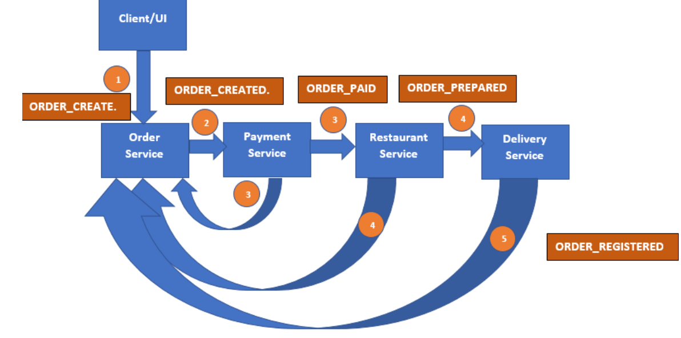
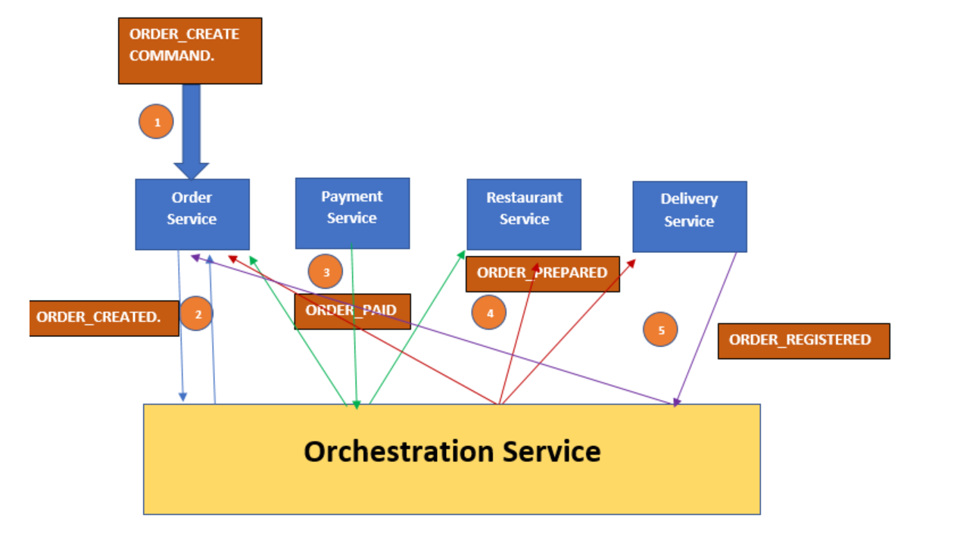

Orchestration
https://www.youtube.com/watch?v=pcyPk2-RVWw
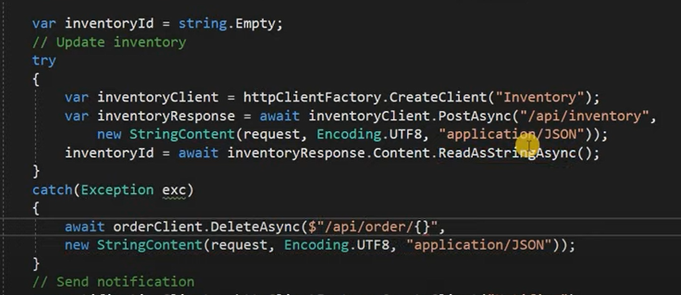

Choreography service
https://www.youtube.com/watch?v=Mau9hxONzZ8

